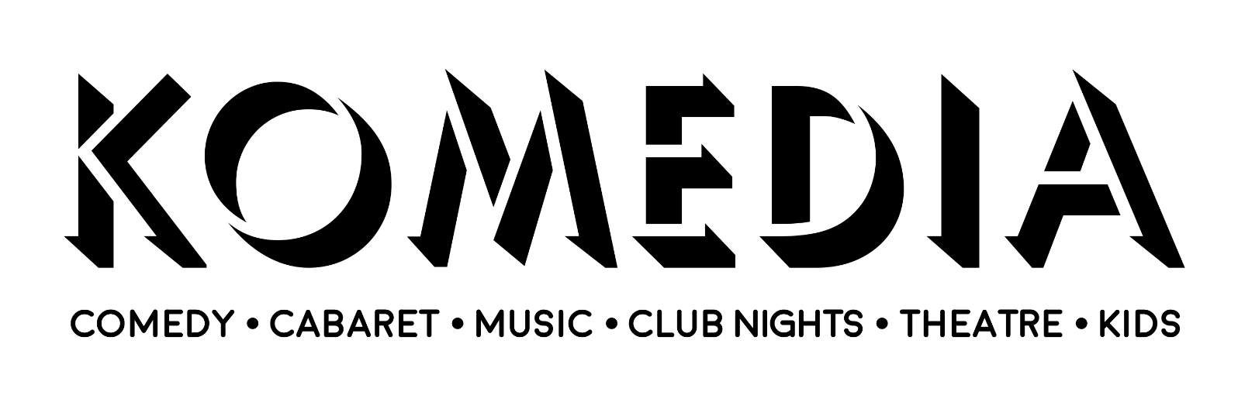

Job description: Duty Manager

Line Manager: Head Duty Manager and General Manager.

Hours: 0 guaranteed, but likely somewhere between 12 and 32 hours per week, depending on applicant/s wishes and availability.

Hourly rate: £14.35 per hour

Overview:
- Manage events and supervise the team whilst we’re open to the public
- Work as part of a team to design processes for running events, and feed back to ensure constant improvement of our operations and safeguard the welfare of our team of operations staff
- Welcome touring productions and visiting performers warmly, and help them to put on the best versions of their shows and performances

Essential skills:

- Excellent management skills
- Excellent planning and organisational skills
- Ability to manage people and act fairly and responsibly in all matters
- Ability to deal with complaints and queries effectively
- Experience in hospitality and/or entertainment across various departments including the bar, FOH, food, security, kitchen, tech, and ticketing
- Love of the arts and live art in particular
- Joy in working with people
- A cool head under pressure

Desirable traits and qualifications:
- Knowledge of Komedia’s specific operations
- Show specific experience from any perspective (stage management, performance, technical work, festival work, etc.)
- First Aid at Work training either historic or currently valid
- Any Health and Safety Qualifications
- BSL at any degree of fluency
- Other transferable workplace or educational qualifications
- Commitments to values in equality and diversity
- Happiness and capability to work varied hours including late at night and (less usually) early in the morning

Main responsibilities and duties:
- As part of the Duty Management team, manage all aspects of the operation on the night including: staffing, promoter/artist liaison, customer service, FOH, security, ticketing, marketing (potentially including announcements and AV), and supporting security when required
- The Duty Manager is the manager to all operational staff including Kitchen staff when Head Chef not present and security/stewards
- Deal with any issues that arise on the night and liaise with the Venue Management Team on issues that are not possible to resolve, ensuring good communications with, and handovers to, daytime staff
- Liaison with Dukes at Komedia Picturehouse and GBK on operational issues on the night.
- Responsible for the handling of cash on the night including cashing off and float checks
- Responsible for the care and security of the building including locking up and management of both intruder alarm and fire panels
- With shared responsibility of making sure that staff training is kept up to date – fire, bar/licence, new starters etc. and the team are made aware of any new protocol or risk assessments carried out by VM Team – e.g. a new type of show is introduced and staff need to know how to run it safely
- Potentially attend regular operation management meetings to communicate and develop current systems
- Maintain an overview of the operation both inside and outside the performance rooms
- To produce effective reporting of events using show reports, and any other reporting available
- Responsible for making sure any shifts under their management are adequately staffed post rota. For example co-ordinating cover for sickness or absence on the day
- Venue aesthetic – reporting any issues relating to upkeep and repairs of the venue and its contents
- Assisting VM Team with other duties when necessary

Perks and Entitlements:

- Holiday pay accrued relative to hours worked
- Pension scheme
- Cycle to Work scheme
- Staff discount at our bars and café
- Complimentary staff tickets to events
- Two free drinks at any in-house show attended
- Complimentary tickets for Dukes at Komedia cinema where available
- Access to perks across a range of local partners

